NAME : MALAIǪA HAǪ ROLL NO. SP22-BCS-008

Ǫuestion No:01

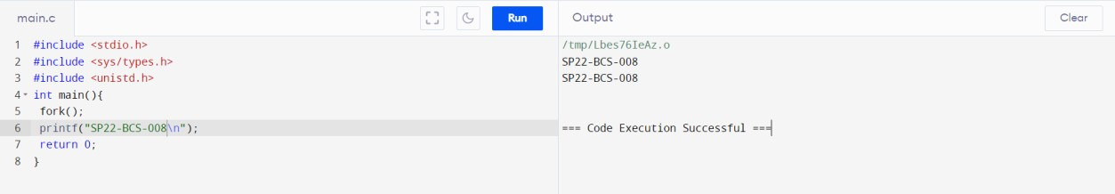

Ǫuestion No 02

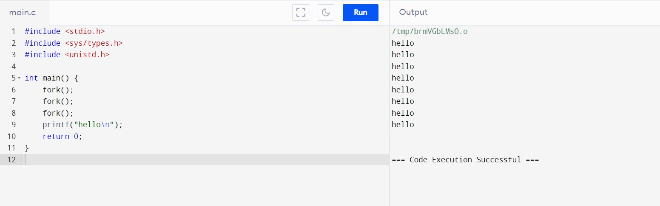

Ǫuestion No 03

